**Meta-analysis diagrams of plant species detection**

**Figure 7: Analysis of the dataset based on the usage in the manuscript**

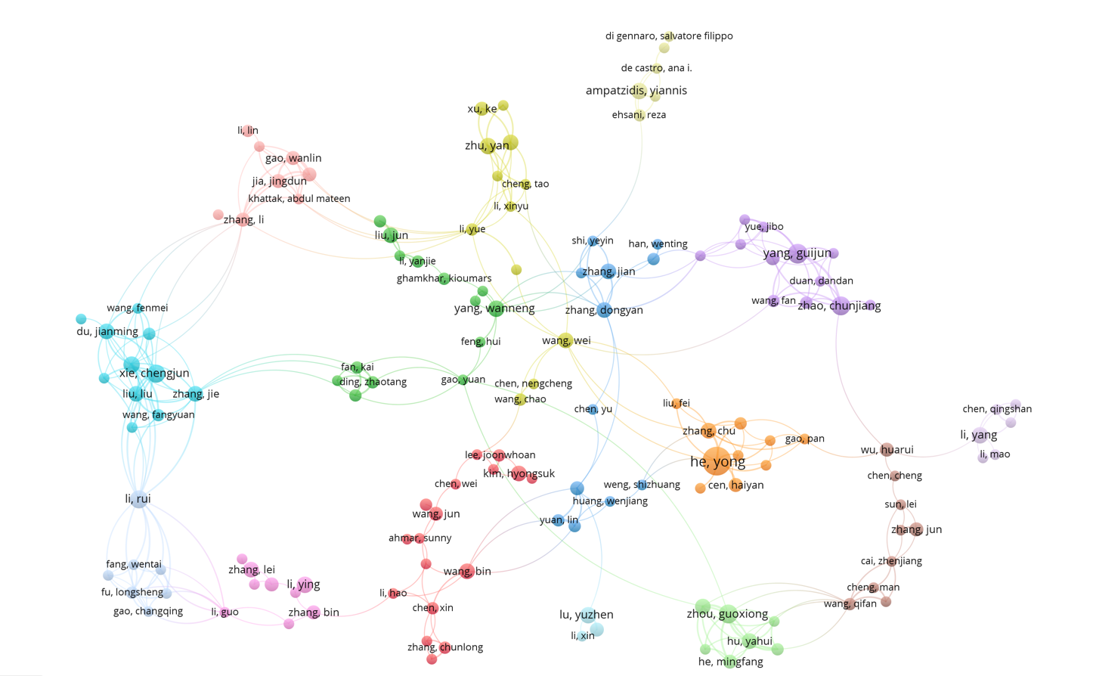

**Figure 8: Analysis of co-authorship among authors of the plant species detection**

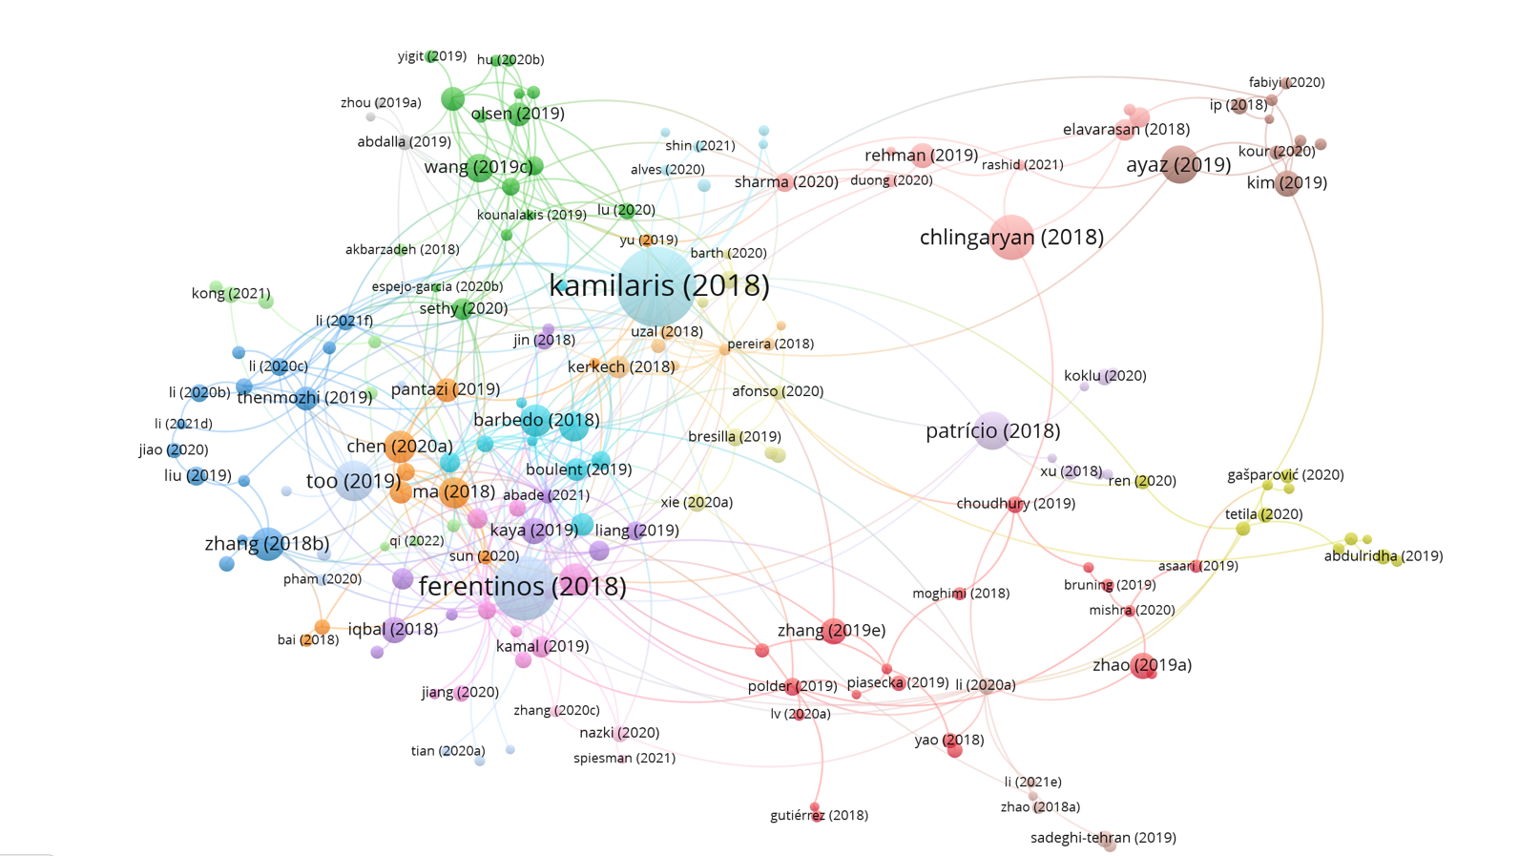

**Figure 9: Analysis of authors based on the citations and the co–citations**

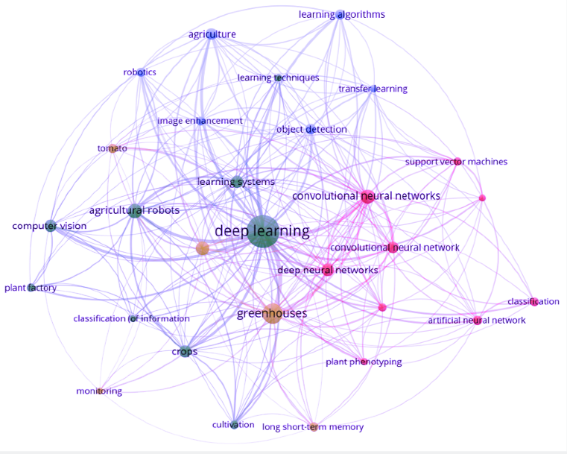

**Figure 10: Analysis based on the keywords used and the linkage in the research area of plant species detection**